**Piceance Mustangs**

**Membership Application**

*Please print, fill out, mail with membership fee to address below, thanks! *

Name: _____________________________________________________________

Address: _____________________________________________________________

City: _____________________________________________________________

State: _____________________________ Zip_____________________ Phone: _____________________________________________________________ Email: _____________________________________________________________

*Individual Membership $20*

Thank you for your support!

Mail to: **Piceance Mustangs**

P.O. Box 1379

Meeker, CO 81641

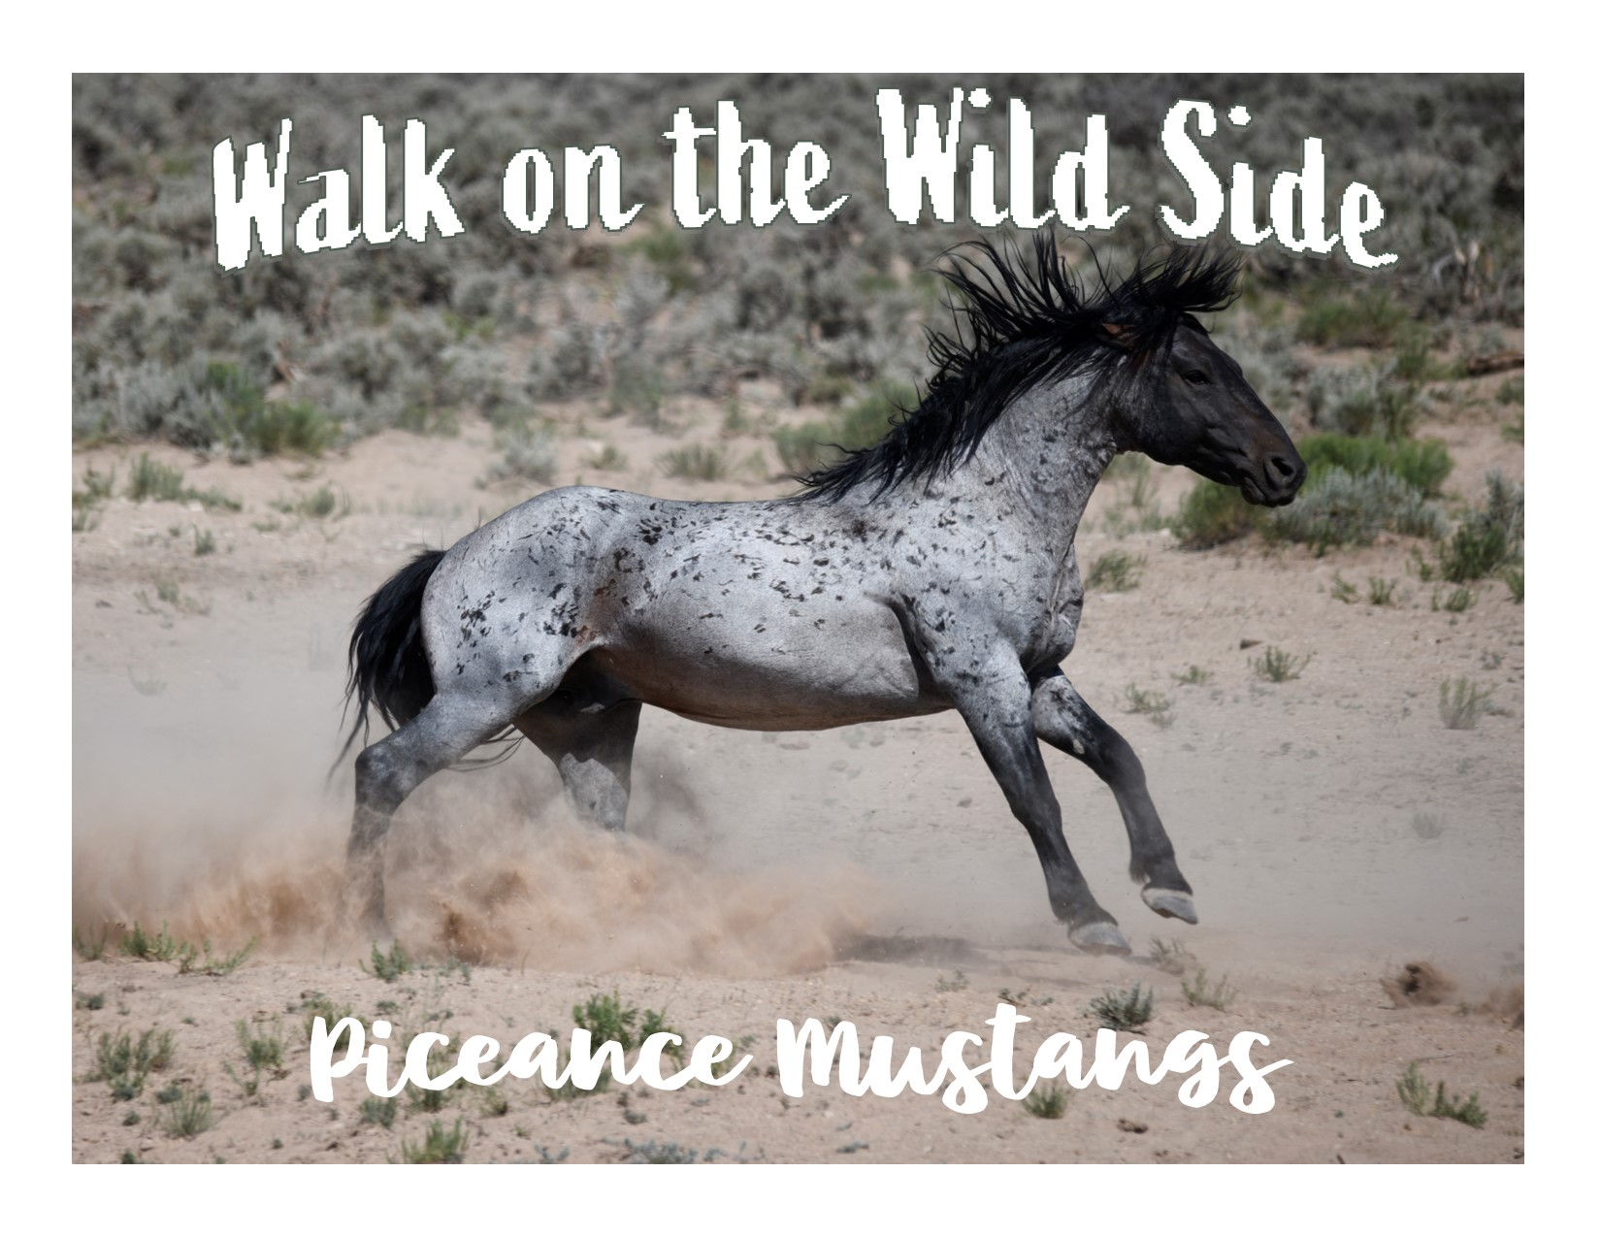

We need you!!!